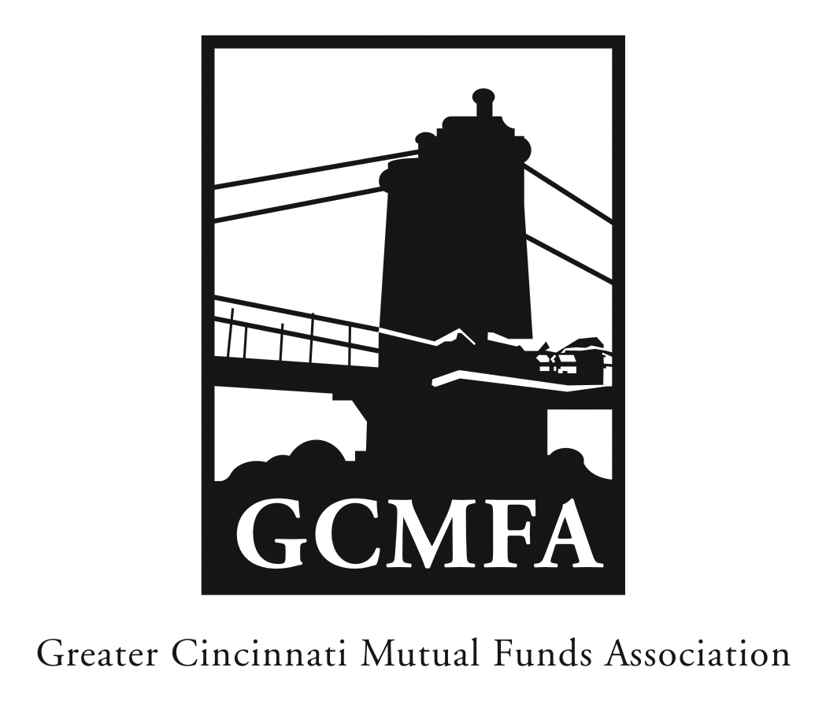  PO Box 31206 / Cincinnati, OH 45231  Phone: 513-939-2652 / Fax: +1- 513-939-2653  www.gcmfa.org / info@gcmfa.org |  |  |  |  |  |  | REGISTRATION FORM  Reservation Deadline 11/27/18
Annual Meeting & Reception
Tuesday, December 4, 2018

University Club

(Parking at Guilford School lot after 5:00 or the Western and Southern Garage)

$60 per person

Company:
Name: |  |  |  |  |  |  |  | Email* Address:
*Confirmation emails will be sent with driving |  |  |  |  |  |  |  | Total Number Attendees
directions one week prior to event. |  |  |  |  |  |  |  | Program Fee |  |  | x $60
 |  |  |  |  |  |  |  | Amount of Remittance |  |  | $

To make a reservation:
1. Fax this form to +1-513-939-2653 or email to info@gcmfa.org
Note: A reservation is a financial commitment
2. Then mail your remittance payable to GCMFA at the above address with a copy of this form
Sorry, no credit cards accepted

Questions? Contact Jill Claire at 513-939-2652

