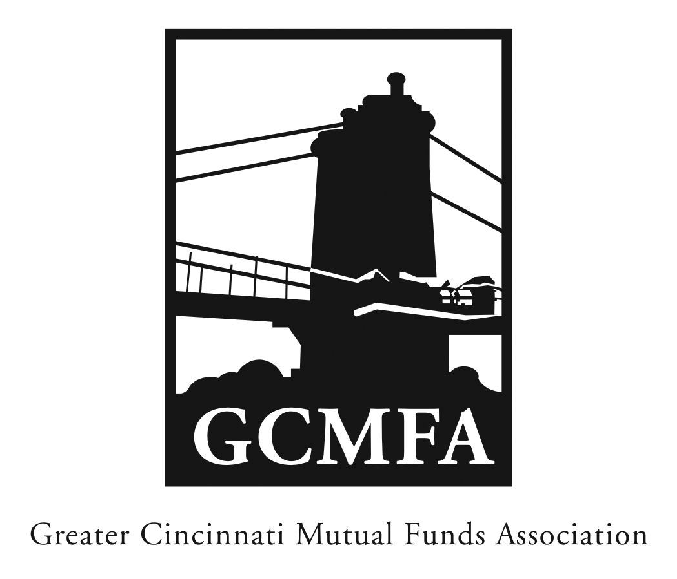  PO Box 31206  Cincinnati, OH 45231  513-939-2652 Phone  513-939-2653 Fax  www.gcmfa.org  info@gcmfa.org |  |  |  | REGISTRATION FORM  Reservation Deadline 5/7/2014

The State of Distribution 2014:
Best Practices in Product Development

Wednesday, May 14, 2014
3:30 pm – 5:00 pm
Scripps Center
312 Walnut Street, 10th Floor
Cincinnati, OH 45202
Company:
Name: |  |  |  |  |  | Email* Address:
*Confirmation emails will be sent |  |  |  |  |  | Total Number Attendees |  | _________
one week prior to event.
To make a reservation:
1. Fax this form to 513-939-2653 or email to info@gcmfa.org
Note: This workshop is FREE for GCMFA member firms.

Questions? Contact Jill Claire at 513-939-2652

