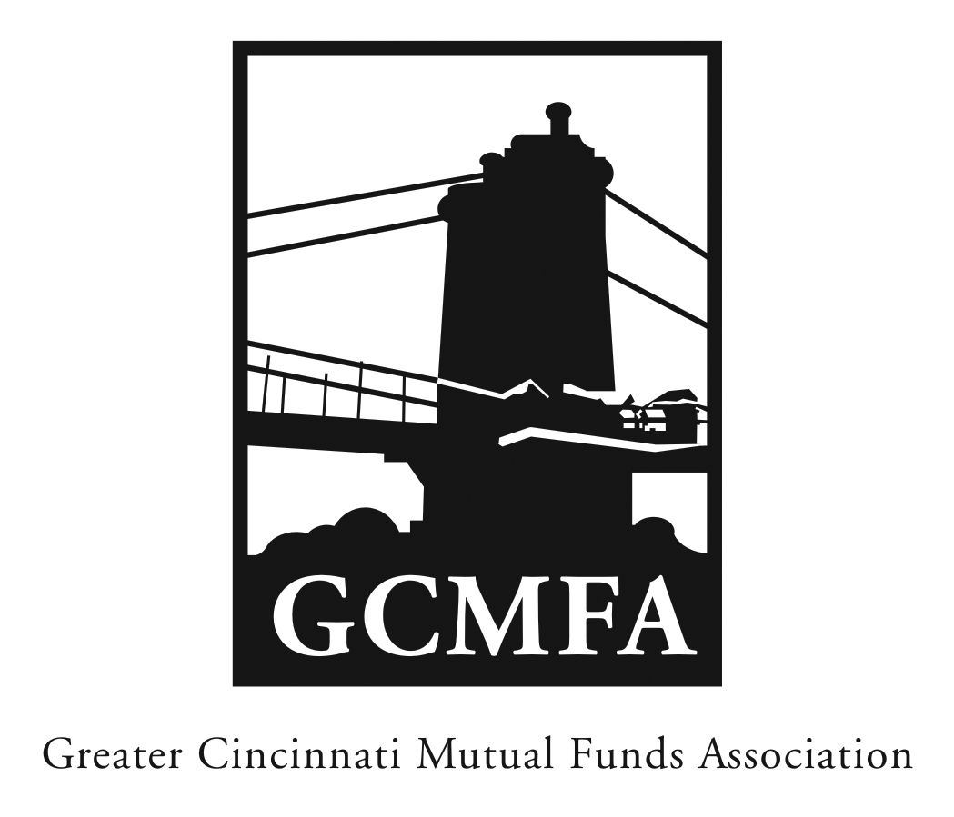  PO Box 31206  Cincinnati, OH 45231  513-939-2652 Phone  513-939-2653 Fax  www.gcmfa.org  info@gcmfa.org |  |  |  | REGISTRATION FORM  Reservation Deadline 6/4/2014

The 2014 Compliance & Operations

Workshop

Wednesday, June 11, 2014
5:30 p.m. – 6:00 p.m. Networking
6:00 p.m. – 7:30 p.m. Workshop

Scripps Center

312 Walnut Street, 10th Floor Conference Room

Cincinnati, OH 45202

(Parking is available in the Scripps Building; garage entrance is on Third Street before Walnut.)

Company:
Name: |  |  |  |  |  | Email* Address:
*Confirmation emails will be sent |  |  |  |  |  | Total Number Attendees |  | _________

one week prior to event.

To make a reservation:

1. Fax this form to 513-939-2653 or email to info@gcmfa.org

Note: This workshop is FREE for GCMFA member firms.

Questions? Contact Jill Claire at 513-939-2652

