

The 2016 GCMFA Compliance & Operations Workshop

Tuesday, June 21, 2016 | 4:30 pm – 5:00 pm Networking
5:00 pm – 6:30 pm Workshop
Scripps Center Conference Room
312 Walnut Street, 10th Floor
Cincinnati, OH 45202
(Parking available in Scripps Center garage)

Recapping the Investment Management Conference and
ICI Compliance & Operations Conference - Topics Include:
- Proposed Liquidity Management Rules for Mutual Funds & ETFs
- Distribution in Guise and Rule 12b-1
- Impact of the DOL Fiduciary Rule on Mutual Funds and Managers
- Proposed Derivatives Rules for Registered Funds
- Lightning Round – Highlighting other Topics of Interest
Guest Panelists:
- Tom Knipper, Ameritas Investment Partners
- Cassandra Borchers, Thompson Hine LLP
- Martin Dean, Ultimus Fund Solutions

The Seminar is open to all employees in your organization, a benefit of your membership and participation in the Greater Cincinnati Mutual Funds Association.

Please forward this notice to other associates who may benefit from participation (i.e. portfolio management, call center & transfer agent teams, marketing department, etc.)

Attending a GCMFA event provides financial professionals continuing education and the opportunity to interact and network with their peers who face the same daily challenges.

Program is Free to GCMFA members!

$100 non-member fee.
Deadline for Reservations: June 14, 2016
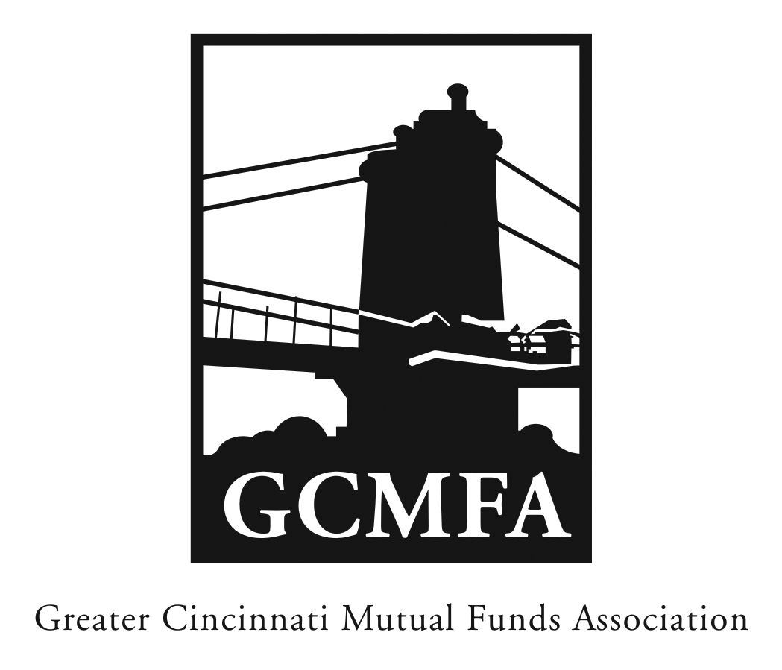
PO Box 31206
Cincinnati, OH 45231
513-939-2652 Phone
513-939-2653 Fax
www.gcmfa.org
info@gcmfa.org

Executive Board of Trustees:

Chairman & President
Brenda Fleissner
Ernst & Young LLP
513-612-1597
brenda.fleissner@ey.com

Treasurer
Jeff Moeller
Ultimus Fund Solutions, LLC
513-587-3445
jmoeller@ultimusfundsolutions.com

Secretary
Marc Figgins
Johnson Mutual Funds
513-661-3100
mfiggins@johnsoninv.com

Trustees

Cassandra Borchers
Thompson Hine, LLP
513-352-6632
Cassandra.Borchers@thompsonhine.com

Rick Ille
ClearArc Capital, Inc.
513-534-7583
Rick.Ille@ClearArcCapital.com

Tom Knipper
Ameritas Investment Partners
513-632-1681
tknipper@ameritas.com

Robert Velotta
Cohen Fund Audit Services, Ltd.
216-774-1126
rvelotta@cohenfund.com

Ryan Wheeler
Fund Evaluation Group, LLC
513-719-5073
rwheeler@feg.com

Terrie Wiedenheft
Touchstone Investments
513-362-8242
terrie.wiedenheft@touchstoneinvestments.com

