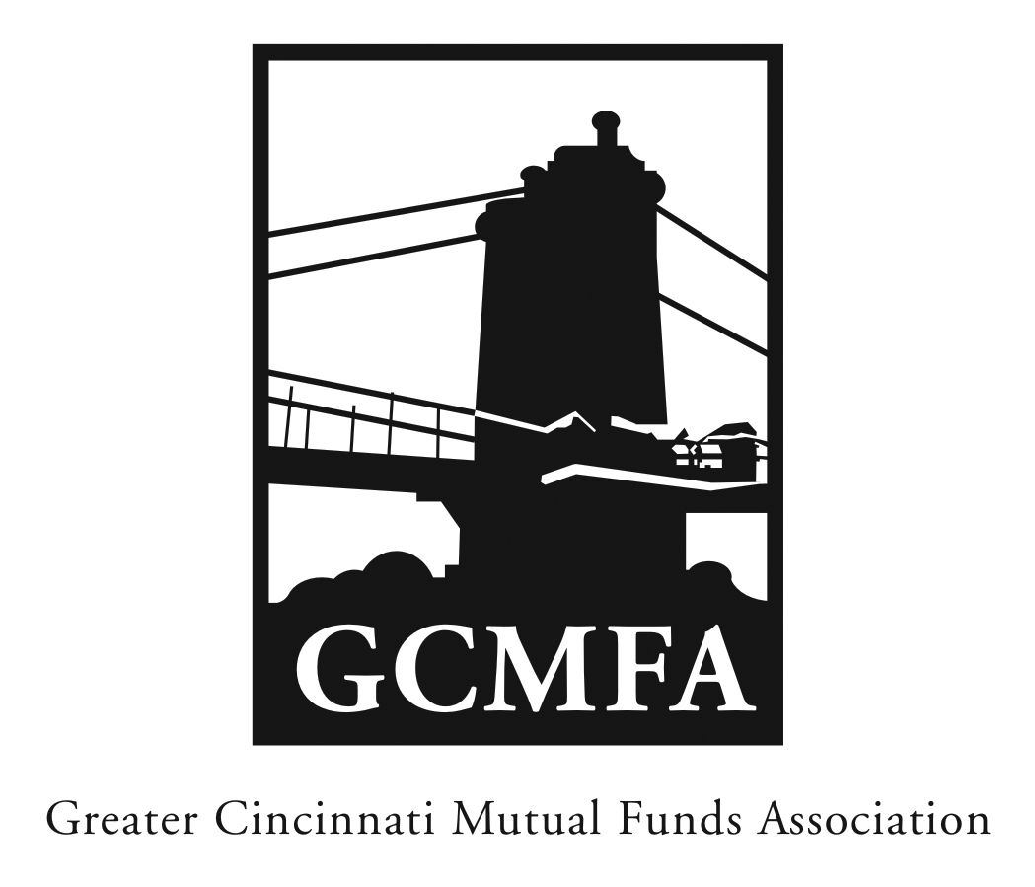  PO Box 31206  Cincinnati, OH 45231  513-939-2652 Phone  513-939-2653 Fax  www.gcmfa.org  info@gcmfa.org |  |  |  | REGISTRATION FORM  Reservation Deadline 5/10/2017

The 2017 GCMFA Distribution Workshop
“Targeted Distribution”

Wednesday, May 17, 2017
5:00 pm – 7:00 pm
The Guilford Building
421 E. 4th St.
Cincinnati, OH 45202
Company:
Name: |  |  |  |  |  | Email* Address:
*Confirmation emails will be sent |  |  |  |  |  | Total Number Attendees |  | _________
one week prior to event.
To make a reservation:
1. Fax this form to 513-939-2653 or email to info@gcmfa.org
Note: This workshop is FREE for GCMFA member firms.

Questions? Contact Jill Claire at 513-939-2652

