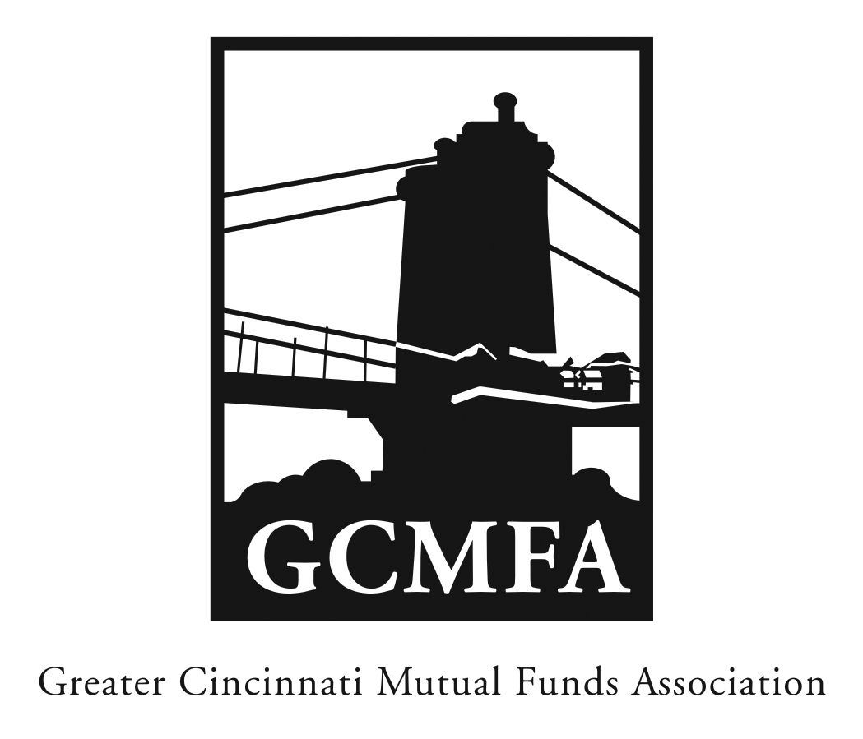  PO Box 31206  Cincinnati, OH 45231  513-939-2652 Phone  513-939-2653 Fax  www.gcmfa.org  info@gcmfa.org |  |  |  | REGISTRATION FORM  Reservation Deadline 5/30/2017

The 2017 Compliance & Operations

Workshop

Tuesday, June 6, 2017
3:30 p.m. – 5:00 p.m. Workshop

University Club

401 E. 4th St.

Cincinnati, OH 45202

Company:
Name: |  |  |  |  |  | Email* Address:
*Confirmation emails will be sent |  |  |  |  |  | Total Number Attendees |  | _________

one week prior to event.

To make a reservation:

1. Fax this form to 513-939-2653 or email to info@gcmfa.org

Note: This workshop is FREE for GCMFA member firms.

Questions? Contact Jill Claire at 513-939-2652

