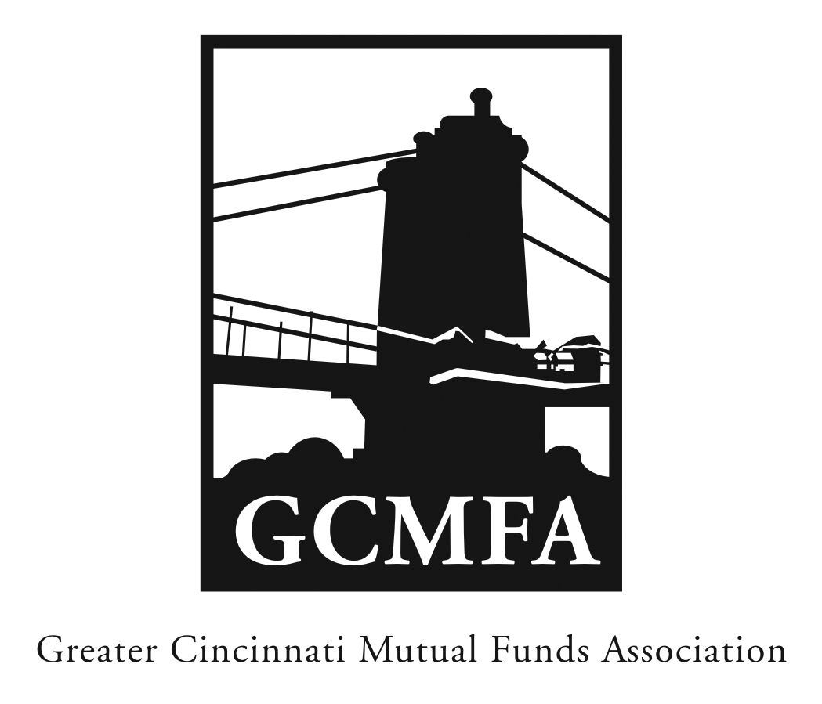  PO Box 31206  Cincinnati, OH 45231  513-939-2652 Phone  513-939-2653 Fax  www.gcmfa.org  info@gcmfa.org |  |  |  |  | REGISTRATION FORM  Reservation Deadline 10/27/17
19th Annual Mutual Fund
Basic Training
Monday, November 06, 2017
8:30 a.m. – 1:00 p.m.

$35 per person (fee DOES include lunch) ~ $100 non-member fee

Company:
Name: |  |  |  |  |  | Email* Address:
*Confirmation emails will be sent with driving |  |  |  |  |  | Total Number Attendees
directions one week prior to event. |  |  |  |  |  | Program Fee |  | x $35
 |  |  |  |  |  | Amount of Remittance |  | $

To make a reservation:

1. Fax this form to 513-939-2653 or email to info@gcmfa.org

Note: A reservation is a financial commitment

2. Mail your remittance payable to GCMFA at the above address with a copy of this form

Sorry, no credit cards accepted

Questions? Contact Jill Claire at 513-939-2652

