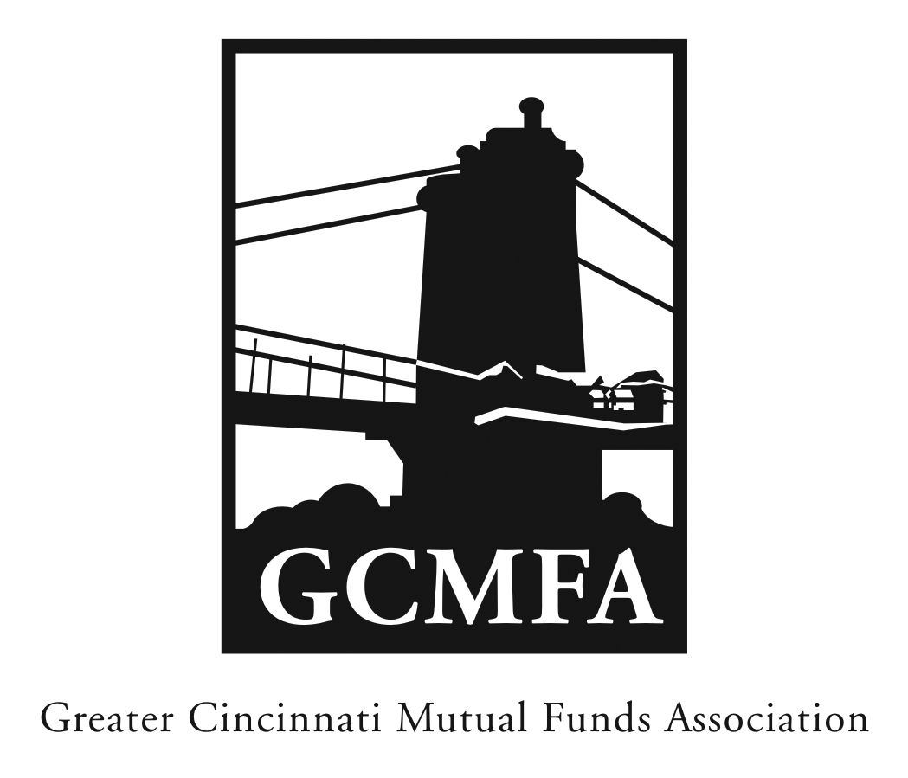  PO Box 31206  Cincinnati, OH 45231  513-939-2652 Phone  513-939-2653 Fax  www.gcmfa.org  info@gcmfa.org |  |  |  |  | REGISTRATION FORM  Reservation Deadline 10/17/17

Accounting Workshop
Tuesday, October 24, 2017
4:30 p.m. – 5:00 p.m. networking
5:00 p.m. – 6:30 p.m. workshop

Guilford Building, Enterprise Hall

421 E 4th Street

Cincinnati, OH 45202

Company: | Ameritas Investment Partners
Name: |  |  |  |  |  | Email* Address:
Tom Knipper |  |  |  |  |  | tgk@ameritasip.com
*Confirmation emails will be sent with driving |  |  |  |  |  | Total Number Attendees |  | 1

directions one week prior to event.

To make a reservation:

1. Fax this form to 513-939-2653 or email to info@gcmfa.org

Questions? Contact Jill Claire at 513-939-2652

