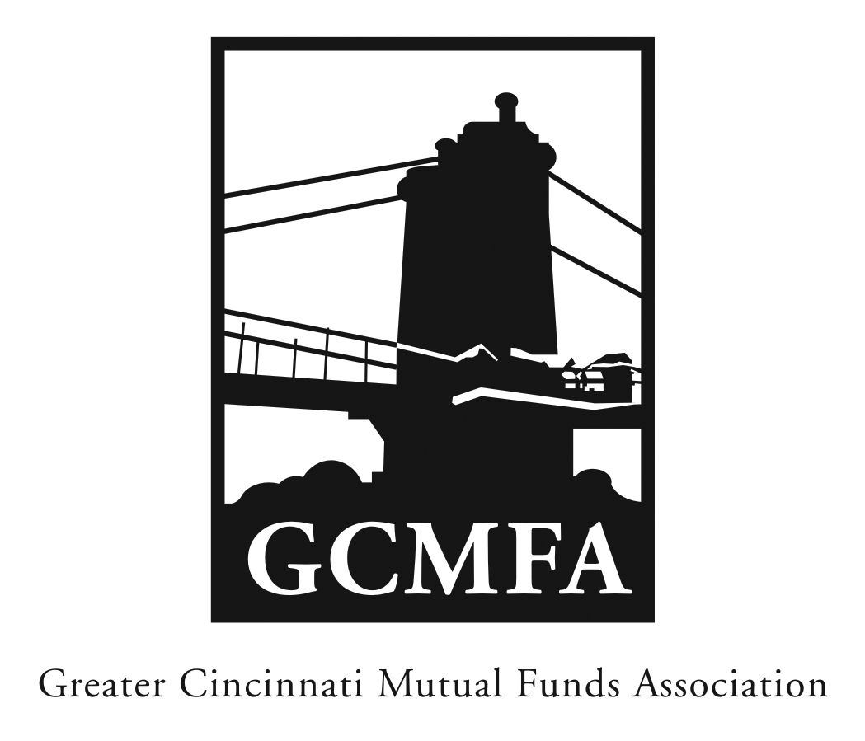  PO Box 31206  Cincinnati, OH 45231  513-939-2652 Phone  513-939-2653 Fax  www.gcmfa.org  info@gcmfa.org |  |  |  |  | REGISTRATION FORM  Reservation Deadline 2/27/18

Developments in Fund Technology
& Cryptocurrency
Monday, March 5, 2018
4:30 p.m.

MadTree Brewing Company

3301 Madison Road

Cincinnati, Ohio 45209

Company:
Name: |  |  |  |  |  | Email* Address:
*Confirmation emails will be sent with driving |  |  |  |  |  | Total Number Attendees

directions one week prior to event.

To make a reservation:

1. Fax this form to 513-939-2653 or email to info@gcmfa.org

Questions? Contact Jill Claire at 513-939-2652

