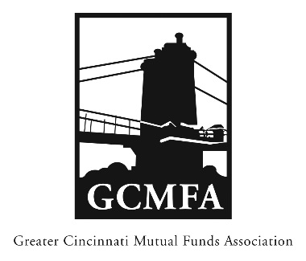  PO Box 31206  Cincinnati, OH 45231  513-939-2652 Phone  513-939-2653 Fax  www.gcmfa.org  info@gcmfa.org |  |  |  | REGISTRATION FORM  Reservation Deadline 7/3/2018

The 2018 GCMFA Distribution Workshop (free)
and FC Cincinnati vs Charlotte Independence ($30 ea.)

Wednesday, July 18, 2018
5:00 pm – 6:30 pm (Match at 7:30)
The University of Cincinnati
(Tangeman University Center, Room 400B)
Company:
W=Workshop Only, M = Match Only, B = Both
Name: |  |  |  |  |  | Email* Address:
*Confirmation emails will be sent |  |  |  |  | Total Number FC Tickets
one week prior to event. |  |  |  |  | Ticket Fee |  |  | x $30
 |  |  |  |  | Amount of Remittance |  |  | $
To make a reservation:
1. Fax this form to 513-939-2653 or email to info@gcmfa.org
Note: A reservation is a financial commitment
2. Then mail your remittance payable to GCMFA at the above address with a copy of this form
Sorry, no credit cards accepted
Questions? Contact Jill Claire at 513-939-2652

