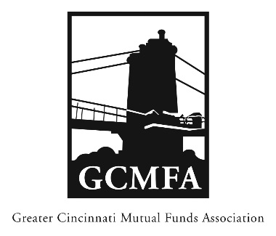  PO Box 31206  Cincinnati, OH 45231  513-939-2652 Phone  +1-513-939-2653 Fax  www.gcmfa.org  info@gcmfa.org |  |  |  | REGISTRATION FORM  Reservation Deadline 9/4/2018

GCMFA Networking Open House (free)

Thursday, September 13, 2018
5:00 pm – 8:00 pm
Rhinegeist Brewery, Annex Room
(1910 Elm Street, Cincinnati, OH 45202)
Company:
Name: |  |  |  |  |  | Email* Address:
*Confirmation emails will be sent
one week prior to event.
To make a reservation:
1. Fax this form to +1-513-939-2653 or email to info@gcmfa.org
Note: A reservation is a financial commitment
2. Then mail your remittance payable to GCMFA at the above address with a copy of this form
Sorry, no credit cards accepted
Questions? Contact Jill Claire at 513-939-2652

