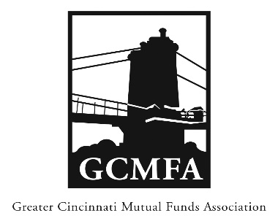  PO Box 31206  Cincinnati, OH 45231  513-939-2652 Phone  +1-513-939-2653 Fax  www.gcmfa.org  info@gcmfa.org |  |  |  | REGISTRATION FORM  Reservation Deadline 10/23/2018

The 2018 Compliance, Tax & Accounting Workshop

Tuesday, October 30, 2018
11:30 a.m. – 1:30 p.m. Workshop

Scripps Center

312 Walnut St., 10th Floor Conference Room

Cincinnati, OH 45202

Company:
Name: |  |  |  |  |  | Email* Address:
*Confirmation emails will be sent |  |  |  |  |  | Total Number Attendees |  | _________

one week prior to event.

To make a reservation:

1. Fax this form to +1-513-939-2653 or email to info@gcmfa.org

Note: This workshop is FREE for GCMFA member firms.

Questions? Contact Jill Claire at 513-939-2652

