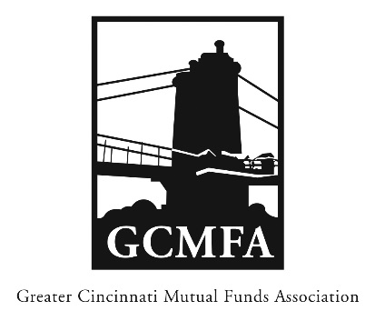  PO Box 31206  Cincinnati, OH 45231  513-939-2652 Phone  1+513-939-2653 Fax  www.gcmfa.org  info@gcmfa.org |  |  |  |  | REGISTRATION FORM  Reservation Deadline 3/18/19

The Challenges and Opportunities

of Cannabis Investing
Tuesday, March 26, 2019
4:30 p.m. Networking
5:00 p.m. Presentation

MadTree Microbrewery

3301 Madison Road

Cincinnati, Ohio 45209

Company:
Name: |  |  |  |  |  | Email* Address:
*Confirmation emails will be sent with driving |  |  |  |  |  | Total Number Attendees

directions one week prior to event.

To make a reservation:

1. Fax this form to 1+513-939-2653 or email to info@gcmfa.org

Questions? Contact Jill Claire at 513-939-2652

