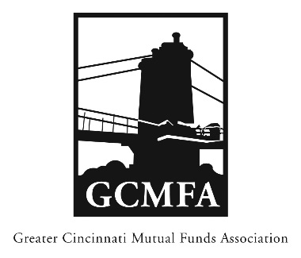  PO Box 31206  Cincinnati, OH 45231  513-939-2652 Phone  +1-513-939-2653 Fax  www.gcmfa.org  info@gcmfa.org |  |  |  |  | REGISTRATION FORM  Reservation Deadline 9/3/19

GCMFA Happy Hour with CFA Society Cincinnati (free)

Tuesday, September 17, 2019
5:00 pm – 8:00 pm
Rhinegeist Brewery, Annex Room

(1910 Elm Street, Cincinnati, OH 45202)

Company:
Name: |  |  |  |  |  | Email* Address:
*Confirmation emails will be sent with driving |  |  |  |  |  | Total Number Attendees

directions one week prior to event.

To make a reservation:

1. Fax this form to +1-513-939-2653 or email to info@gcmfa.org

Questions? Contact Jill Claire at 513-939-2652

